Housing Subsidy Reform – Master Draft Proposal

1. Executive Summary
New York City’s rental subsidy programs have failed to stabilize vulnerable tenants, particularly those targeted by landlords with repeat Housing Court violations. This proposal outlines a conversion pathway to shift these properties into tenant-owned co-ops, using existing subsidy budgets over a five-year period. The Tenant Co-op Acquisition Program (TCAP) offers a fiscally responsible alternative to the revolving-door crisis response system. Our policy ensures oversight, community investment, and long-term affordability without the stigma of welfare models.

2. Introduction
Housing instability in NYC is not just a crisis of affordability—it is a policy failure producing predictable cognitive, educational, and public health costs. While rental subsidies are designed as safety nets, they often entrench cycles of eviction, gentrification, and housing court abuse. This report proposes a structural pivot: converting rent-based subsidies into down payments and reserve contributions for tenant-led co-op conversions. Through this transformation, the city gains an asset-generating solution, and tenants secure long-term housing equity.

3. Literature Review
(Full integration of sources and prior research is ongoing. Currently includes: Vienna case study, NYC housing instability data, mental health correlations, and failure patterns in rent subsidy models.)

4. Methodology & Framework
(Pending)

5. Findings & Analysis
- HPD and DHCR records show repeat code violations in buildings receiving public subsidies.
- NYC’s Top 100 Worst Landlords list features properties with significant public rent subsidy inflows and no tenant ownership option.
- Right to Counsel has decreased eviction filings in some boroughs, but has not addressed asset conversion or ownership.
- Existing subsidies are sufficient to finance initial buyouts if coordinated with housing court diversion and reserve repair budgets.

6. Policy Proposal
**Tenant Co-op Acquisition Program (TCAP)**
- Eligible buildings: Multifamily properties owned by landlords with repeat HPD or Housing Court violations and at least 50% of units receiving public subsidy (e.g., Section 8, CityFHEPS, etc.).
- Conversion trigger: On landlord violation threshold, tenants are offered first right of refusal via city-financed co-op conversion.
- Public funds redirected to:
1. Initial buy-in payment (treated as equity, not subsidy)
2. Repair reserve (building systems, code compliance)
3. HOA/Co-op reserve account (5-year stabilization buffer)

**Oversight:**
- Joint supervision from HPD, DHCR, Housing Court, and tenant-elected board
- Fiscal management through participating credit unions or community development banks

**Narrative Reframing:**
- Avoid use of “subsidy” in legislative language—frame instead as: _“Public Equity Transfer Framework”_ or _“Asset-Based Stability Plan”_
- Messaging focuses on **return on public investment**: stable communities, reduced evictions, lowered court/legal costs, and public savings from reduced emergency placements and hospitalizations

7. Implementation Plan
(Pending)

8. Evaluation Metrics
(Pending)

9. Conclusion
The proposed Tenant Co-op Acquisition Program shifts the housing conversation from crisis containment to community equity. This approach prioritizes fiscal responsibility while addressing the structural inequalities embedded in NYC’s rental market. By converting subsidy dependence into ownership potential, the city can deliver both budgetary returns and public justice.

Appendices: Visual Data & Trends

Figure A1: NYC Housing Tenure Trends (2000–2021)
This chart illustrates the continued dominance of renter-occupied housing in NYC, reinforcing the need to convert subsidies into ownership opportunities.
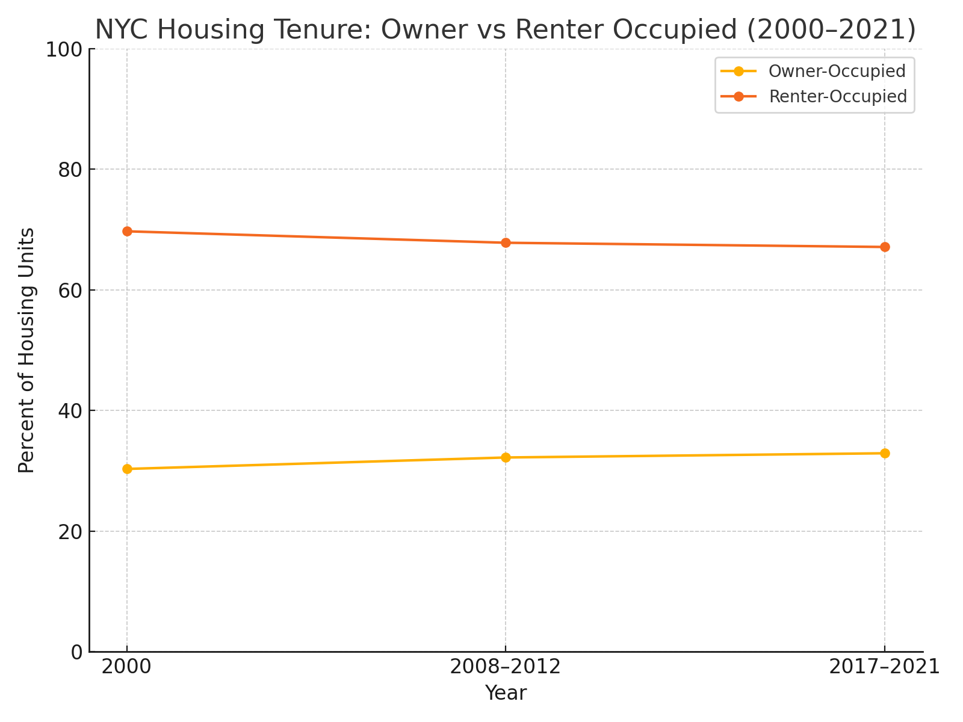

Figure A2: Racial Disparities in Homeownership (2000–2021)
Ownership rates by race demonstrate persistent disparities and support the proposal’s targeted equity-based co-op conversion model.
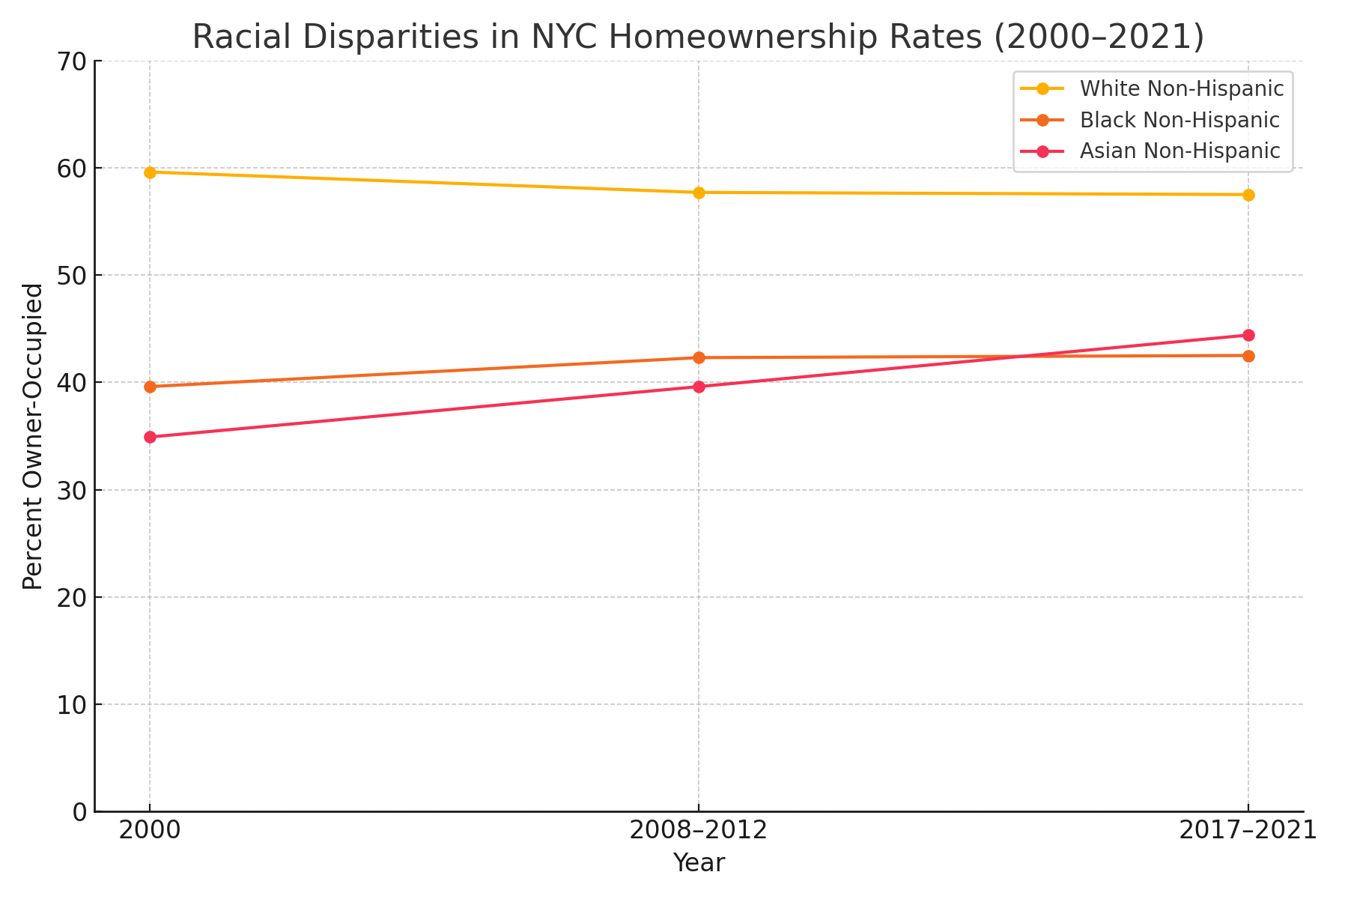

Figure A3: Public Cost vs. Wealth Return Comparison
This chart contrasts the 10-year public cost and wealth outcomes of the Emergency Shelter System versus the Tenant-Owned Co-op Model (TCAP). The co-op model offers a threefold return on investment while reducing the public burden, making it a fiscally and socially responsible alternative.
